

***Support to Deepening Foundations for Peacebuilding and Community Security in Kenya: 2014-2018 programme***

***Report: Annual Report 2015***

Table of Contents

I. Executive Summary 3

II. Country Context 4

III. Progress towards Programme Outcomes 5

Outcome 1: Strengthened institutional capacities for policy formulation, implementation and monitoring 6

Support to strengthening institutional capacity to formulate, implement and monitor peacebuilding, conflict prevention, cohesion, community security and arms control: 6

Outcome 2: Reduced community security threats and improved response to conflicts, risks and disasters 7

Support to operationalizing national and county coordination mechanisms, preparedness, early warning, timely response, community security and recovery systems: 7

National Level Coordination: 7

County Level Coordination strengthened: 7

Council of Governors (COG) engagements: 8

Strengthened capacity of County Governments: 8

Reduction in the flow of illicit small arms and light weapons in North Rift: 9

Countering Violent Extremism (CVE) and de-radicalisation supported: 9

Enhanced capacity for monitoring and researching of crime trends: 9

Area-based and cross-border programs rolled-out to boost sub-regional peace and development: 10

Outcome 3: Enhanced mainstreaming of peacebuilding, reconciliation and community security in development agenda 10

Support to promoting national unity, reconciliation, cohesion, resilience and integration at national and county levels: 11

OUTCOME 4: Enhanced Results Based Management, strategic partnerships and coordination at the Programme level 14

Support to strengthening capacities for programme management, strategic partnerships and programme coordination: 14

Strategic engagements 14

VI. Challenges and Lessons Learned 15

Challenges: 15

Lessons Learned: 16

VII. Conclusions and Way Forward 17

# I. Executive Summary

As Kenya continued to enjoy significant international attention and activities from hosting the President of the United States of America and the Pope to holding the 10th World Trade Organization as the first African state since its inception in 1994; there were a number of other factors that made the dynamics of sustaining peace and national cohesion a challenge. This is particularly so in face of the fact that the country is fast approaching the electioneering mood. There are challenges to national security with acts of terrorism; violent conflicts and crimes perpetuated by illicit firearms; conflicts around land ownership, use, allocations and access; continued tensions between communities; crescendo in incidences of political incitement and hate speech; as well as corruption.

During the period under review, July-December 2015, the Peacebuilding and Community Security programme endeavoured to have in place a number of factors critical for securing peaceful elections in 2017 while at the same time addressing current challenges to peace, security and cohesion. The programme focused on processes that facilitated development and passing of necessary legislation; imparted critical and requisite skills and knowledge for effective peacebuilding, conflict prevention, management and resolution; strengthened institutional capacities for policy formulation and implementation, programme management, enhancing social cohesion, research and documentation, as well as conflict prevention, management and resolution; built strategic partnerships and collaborations to enhance coordination, cooperation and consultations among key national and county actors; and (re)established mechanisms and platforms for supporting peace, cohesion, community security, gender integration, research and conflict management.

The programme recorded a number of positive achievements that will prove strategic in not only consolidating Kenya’s peace process, but also contributing towards peaceful general elections in 2017. Key achievements include the passing of the Sessional Paper No.5 of 2014 on Peacebuilding and Conflict Management in Kenya (adopted by the National Assembly in August 2015); upgrading of the National Conflict Early Warning and Early Response System; review of guidelines for establishing Local Peace Committees, as well as reviewing membership and terms of reference of the National Steering Committee on Peacebuilding and Conflict Management; initializing the process of reviving the *UWIANO* Platform for Peace; enhanced engagement of County Governments through capacity building efforts, consultations and strategic engagement with the Council of Governors; capacity building of National Police Reserves to enhance community security; establishment of platforms for supporting peace and cohesion; capacity building efforts to inculcate skills and knowledge on cohesion; as well as continued research on crime and crime trends and monitoring of crime reporting.

This report documents some of the key interventions, strategies, mechanisms and frameworks that have been put in place. It further outlines some of the challenges experienced, as well as a snapshot of anticipated activities for the first half of 2016.

# II. Country Context

During the period July-December 2015, Kenya continued to experience mixed fortunes ranging from incidences of insecurity and economic crimes to global events held locally. These factors contributed directly or indirectly to the state of peace, cohesion and security. Key among these factors include:

**High Profiled Diplomatic Developments**Some of the positive highlights for the country during the last half of 2015 included: hosting two of the most prominent personalities in the world. In July, the country hosted the President of the United States of America and in November, the Pope visited Kenya. As the year came to a close, the country hosted the 10th World Trade Organization (WTO) Ministerial Conference in Nairobi. All these high profile events signify the strides that the country is taking towards bolstering its economy and security. The lifting of the travel advisories further indicates the growing confidence in Kenya by the world on its fight against terrorism and insecurity in general.

**Security and Socio-cultural Developments**

*National Security* - On 2nd April 2015, the country suffered one of its most horrific terrorist attacks by the terrorist group Al-Shabaab. The attack at Garissa University College left 147 dead and more than 79 injured. The attack underscored the threat posed to the country by the terrorist outfit and the need to address the issue comprehensively through a multi-dimensional approach. Through the National Counter Terrorism Center (NCTC) and other security agencies, various initiatives were put in place to combat radicalization and prevent further attacks. These included the operation by the combined forces in Boni Forest of Lamu in September to flush out the Al-Shabaab Militants, improved gathering and sharing of actionable intelligence, enhanced security presence, Counter Violent Extremism strategies such as engaging Muslim clerics to counter the extremists’ narratives and issuance of amnesty for returnees who continue to respond to the amnesty by the National Government. Further, the government increased budgetary allocation to security sector and allocated KSh 223.9 billion in the 2015/2016 financial year, which has strengthened national security and counter terrorism efforts[1]. Evidently all these have worked since there have not been any major terror related activities in the country after the April 2015 attack.

*Community Security* - During 2015, various issues affected community security. Crime perpetrated by criminal or organized gangs was mainly experienced within the urban areas mainly in Kisumu, Nairobi, Nakuru and Mombasa. Unemployment played a major role in providing the perpetrators of crime while the availability of illicit Small Arms and Light Weapons (SALW) fuelled crime. Conflicts related to land use, access and demarcation also affected community security in 2015. There were boundary disputes between segments of the population in a number of counties, namely Samburu and Isiolo, Narok and Kisii, Kericho and Kisumu, Kisumu and Vihiga, Kericho and Kisii, and Taita Taveta and Kwale, among others. Eight (8) such conflicts were reported during the period.Cattle rustling and inter-ethnic clashes were majorly reported in the pastoral areas especially in Baringo, Samburu, Turkana, Pokot, Isiolo and at the border points of Isiolo and Meru counties. Incompatibility emanating from border issues, SALW availability and competition over pasture and water were said to be the main conflict contributing factors. Fifteen (15) incidents resulting from cattle raids were reported with 28deaths and 7 injuries, while 6 were reported on inter-ethnic clashes. Crime rates in areas where community policing has been implemented have reduced by up to 40%[2].

*Social Cohesion* - Significant effort was made towards national healing and reconciliation. In line with the recommendations of the Truth, Justice and Reconciliation Commission Report, the government made a public apology for all historical injustices perpetuated throughout the country’s history and established a USD 10 million fund for restorative justice[3]. However, incitement and hate speech hit a crescendo as the political leaders increasingly spewed utterances that had the likelihood of sparking hatred amongst the different communities or political tensions in the country.

**Political Landscape**

The ICC process continued to generate heat on the political front as politicians intensified prayer rallies across the country. Similarly, discourse related to referenda took a higher notch as various groups embarked on collecting signatures from the public to support their campaigns. Among the referenda calls were the Governor’s *Pesa Mashinani* (money in the grassroots) aimed at increasing the allocation of revenue to County Governments; *Okoa (save) Kenya* campaign aimed at increasing resource allocation to the Counties, among others.

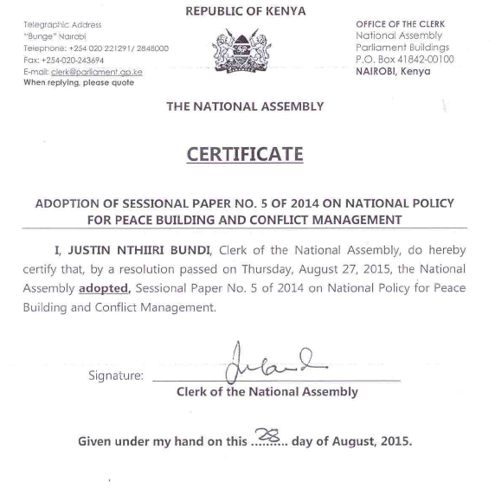**Legislation and Policy context**

The Adoption of Sessional Paper No. 5 of 2014 on Peacebuilding and Conflict Management in August 2015 by the National Assembly signified the intention of the country to shift from *ad hoc* peace work to policy driven processes. The adoption paves way for the grounding of the Policy through the law as an Act of Parliament. This will go a long way in ensuring the Government devotes adequate resources towards mitigating conflicts and sustaining the peace efforts and at the same time ensuring sufficient coordination. Other notable efforts during the period, include reaching out to the Security and Foreign Relations Committee of the Council of Governors for enhanced coordination of peace and cohesion agenda in the context of devolution.

# III. Progress towards Programme Outcomes

The programme worked towards enhanced peacebuilding, community security and cohesion, through the following outcomes:

1. Strengthened institutional capacities for policy formulation, implementation and monitoring;
2. Reduced community security threats and enhanced response to conflicts, risks and disasters;
3. Enhanced mainstreaming of peacebuilding, reconciliation and community security in the development agenda; and
4. Enhanced results based management, strategic partnerships and coordination at programme level.

## Outcome 1: Strengthened institutional capacities for policy formulation, implementation and monitoring

Significant strides were made in establishment of requisite legislation, strategies and mechanisms that facilitate effective and coordinated conflict prevention, management and resolution.

Support to strengthening institutional capacity to formulate, implement and monitor peacebuilding, conflict prevention, cohesion, community security and arms control:

**Enhanced legislative and policy agenda -** Protection Against Domestic Violence Act passed[4]; Sessional Paper on Peacebuilding and Conflict Management passed; NCIC Act under review; The laws and policies have provided clear institutional frameworks for operation and mechanisms for budget allocation.

***Sessional Paper on the National Policy on Peacebuilding and Conflict Management adopted by Parliament*:** Adoption of Sessional paper no. 5 of 2014 on National Policy for Peacebuilding and Conflict Management in August 2015. This was a result of programme partners’ consultations with the Parliamentary Committee on Administration and National Security. Development of the National Peace Council Bill has begun and it is anticipated to be finalized in 2016. The process of drafting the bill has been characterized by participation of both national and county stakeholders. A multi-stakeholder technical team was established to spearhead finalization of the Bill, and comprises representation from Office of the Attorney General, Office of the Deputy President, National Steering Committee Secretariat, the National Cohesion and Integration Commission, Parliament and the Kenya Law Reform Commission.

***Draft Policy and Bill on Small Arms and Light Weapons Developed***: Further, in response to the challenge that illicit SALW bring to the state of peace and cohesion, the Kenya National Focal Point on Small Arms and Light Weapons has spearheaded development of a policy and bill that will address issues regarding armed conflict in Kenya.

***National Police Reserves Policy Formulated****:* Along with these legislative documents, the KNFP has also facilitated formulation of the National Police Reserves Policy that seeks to address the recurrent violent conflicts in pastoralist areas of Kenya.

***National Conflict Early Warning and Early Response System (NCEWERS updated, automated and engendered***: The National Conflict Early Warning and Early Response System (NCEWERS) was updated, automated and engendered paving way for devolution of the NCEWERS to County levels, to facilitate effective and efficient vertical and horizontal response to conflicts.

***Sustained capacity development for institutions*** ensured through development of guidelines, curriculum and training manuals. For example, the Standard guidelines for establishing National and County Peace Structures were reviewed. This has strengthened capacity for coordinating conflict prevention, management and resolution of stakeholders at national and county levels.

## Outcome 2: Reduced community security threats and improved response to conflicts, risks and disasters

Support to operationalizing national and county coordination mechanisms, preparedness, early warning, timely response, community security and recovery systems:

### National Level Coordination:

1. ***Guidelines for Local Peace Structures to aligned to Devolved Governance System****:* A platform for peacebuilding and conflict management actors resulted in review of the guidelines for establishing Local Peace Committees. This review has seen the alignment of the guidelines to the current constitutional dispensation and harmonization with the experiences and lessons of stakeholders.
2. ***Scenario Developed for Country Peace and security Outlook in run up to 2017 General Election****:*  Forums facilitated for national and county stakeholders to develop scenarios for the country based on findings from and national conflict analysis. The scenarios postulated three perspectives on the potential outcomes of the status quo persisting, best case scenario or worst case scenario. Ultimately, the scenario building presents an urgent need for actors to invest more on peace building processes and enactment of critical legislations to avert the worst case scenario.

To enhance coordination, stakeholders outlined critical steps to be taken so as to achieve this including undertaking a mapping of stakeholders; reviewing the NSC membership; reconstituting the NSC Technical Committee and Sub-Committees including revision of the terms of reference for these committees of the NSC; development of a communication strategy for partners and stakeholders at all levels; and devolving the national peace structure to the county levels.

**Process for establishing Inter-agency Coordination Framework for Electoral and Political Conflict Prevention initiated**: The programme has initiated the process of developing a coordination framework that will be strategic in addressing electoral and political challenges in the build-up to the 2017 general elections. This framework shall be under the banner of *UWIANO*. Consensus among stakeholders is for *UWIANO* to be tri-phased around the electioneering period with pre-election, election and post-election phases being factored into the new strategy. This will ideally have a lasting effect and enable stakeholders to respond timely. Further, it is anticipated that *UWIANO* will address emerging issues related to terrorism, devolution and conflicts over natural resources and extractives. Ultimately, UWIANO is envisaged to be the interagency coordination organ before, during and after the upcoming general elections.

### County Level Coordination strengthened:

***25 Counties Supported with Technical Capacity and Resourced to strengthen local peace initiatives and structures:*** The programme was able to support and be part of a concerted effort to re-establish local peace structures. This support was done through provision of technical and resource support targeting the local grassroots initiatives and structures in 25 counties. Some specific achievements during the period under review for West Pokot, Turkana and Baringo Counties include:

* ***West Pokot County***: the county managed to, among other achievements, launch the County Peace Forum with requisite coordination structures at the grassroots level; formation of a directorate for inter-governmental coordination of peace building and disaster management; capacity building of county government administrators through trainings and equipment; and implementation of aspects of the County Integrated Development Plan (CIDP) that contributes to sustainable peace.
* ***Turkana County***: Among other achievements, the county has managed to establish a Directorate of peace; map all peacebuilding stakeholders in the county; implementation of county assembly policies on security and peacebuilding; and appointment of a security advisor to ensure decision making processes in the county are done in a conflict sensitive manner.
* ***Baringo County***: has constituted local peace committees in vulnerable areas of the county (i.e. along border point with Turkana and West Pokot Counties); and cross-border peace activities with Turkana and West Pokot.

Overall, the programme supported county and community conversations in counties in North Rift thereby leading to scaled up and sustained engagement with the political leadership, religious leaders, elders, women, youth, reformed warriors, professionals and the entire community in these Counties leading to relative peace; recovery and return of over 400 raided/stolen livestock. In addition to this, the training provided to County Government officials in thematic areas such as conflict prevention, resolution and management, conflict sensitivity, mediation, dialogue and negotiation led to increased capacity of the County Governments to engage with their counterparts. For instance, there was robust engagement between the County Governments of Turkana and West Pokot; between both County Governments and the neighbouring communities and Governments in Ethiopia, South Sudan and Uganda. Civil society actors have also been very supportive of these initiatives.

Further, a number of County Governments scaled up their focus on peacebuilding and conflict management. Those who budgeted for peace and cohesion and supported peace activities include Turkana, West Pokot, Mandera, Trans Nzoia, Wajir, Isiolo, Marsabit, Bungoma, Migori, Laikipia. West Pokot County Government ebbed other Counties and established an Inter-Governmental Directorate of peacebuilding and disaster management, while Turkana County Government conducted a stakeholders’ mapping predicated on the recommendation of the programme partners.

Council of Governors (COG) engagements: Resulting from COG engagements, there was consensus on establishing a framework that facilitates sustained regular engagement between county governments and peace actors. Further, the forum agreed on the need to engage the County Governments, through the Council of Governors (COG), in the development and implementation of policies and legal frameworks as well as cross-border peace and security activities. The need to continuously build capacity of the COG Secretariat and County Government officials on matters relating to peacebuilding and conflict management. The COG pledged to advocate for integration of peace, cohesion, security and counter violent extremism within the County Integrated Development Plans (CIDPs). The COG also pledged to incorporate conflict sensitive programming approaches and development into the county work plans.

Strengthened capacity of County Governments: In a bid to strengthen county capacities, the programme supported consultative training forums for senior county Government officials and ward administrators from Turkana and West Pokot Counties. This was in response to the historicity of violent conflicts and loss of lives between the two counties. As a result, a number of recommendations were made in the spirit of enhanced peacebuilding and conflict prevention, management and resolution.

* For ***Turkana County***, these included disarmament and enhancing coordination; establishing and supporting peace structures; engage women, youth and persons with disabilities; developing and implementing a Turkana County Peacebuilding and Conflict Management policy in the short-term, as well as peace dividends programmes; re-integration of reformed warriors; resettlement of Internally Displaced Persons (IDPs); and engaging political leadership in the long run.
* For ***West Pokot County***, the county recommended establishing a peace directorate to coordinate peace processes; develop a legal framework for implementing the national peace policy; work with existing peace structures at the national level; and utilize local FM channels to sensitize and create awareness on matters peace among others. Further, the county prioritized development of a conflict early warning and response framework; community connector projects; community social agreements in the short-term as well as integration of peacebuilding, conflict management and cohesion in CIDPs; addressing boundary related issues; and sustained collaborative partnerships with Turkana, Elgeyo Marakwet and Trans Nzoia Counties in the long run.

Reduction in the flow of illicit small arms and light weapons in North Rift:has resulted from extensive stakeholder consultations and on-going peace initiativesinTrans Nzoia, West Pokot, Turkana, Baringo and Elgeyo Marakwet counties.

Countering Violent Extremism (CVE) and de-radicalisation supported:Program has supported a pilot on “Strengthening Community Resilience against Violence, Extremism and Radicalization”, covering the coastal and north-eastern regions of Kenya. This builds on experiences from other UNDP programs on community security and armed violence under which a number of former fighters in Al-Shabaab (in informal settlements in Nairobi and Coastal towns), and in organised armed groups and raiders in pastoral communities were assisted through rehabilitation and reintegration initiatives. As a result, community structures have been established in Mombasa, Lamu, Garissa and Mandera and integrated into the peace infrastructures. The CVE program has taken a peace building approach, incorporating conflict sensitivity, and gender dimensions. A consultative platform on CVE has been established as a mechanism through which government and stakeholders analyze and provide advise on appropriate responses to CVE.

Enhanced capacity for monitoring and researching of crime trends:Continuous collection of data from print media, digital media, as well as crimes statistics from the National Police Service were supported. This data was utilized to undertake research as well as document crime trends. Two (2) reports and policy briefs were produced which in turn influenced security response. Access to the reports was enhanced through setting up of an electronic crime database. A survey on crime hotspots in Nairobi County with specific focus on the slum areas[5] was undertaken, building on previous surveys that focused on major crime trends in Kenyan slums.

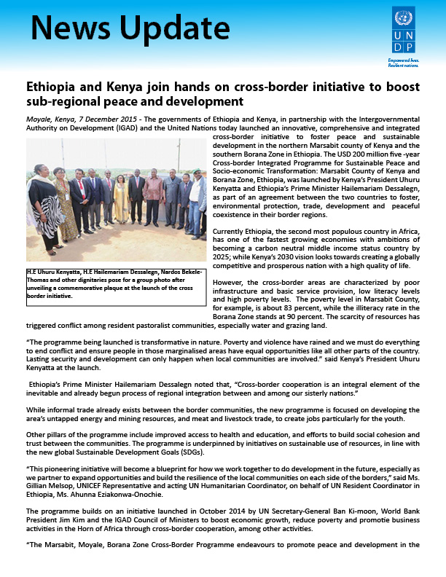Area-based and cross-border programs rolled-out to boost sub-regional peace and development: Area-based and integrated programmes have been supported in Turkana and Marsabit counties, which have seen a decrease in conflicts, as well as increased transparency and accountability by both county governments and development partners operating in those counties. On building social cohesion between cross-border communities, the program worked closely with the UN Country Team in developing a new Flagship Kenya-Ethiopia Programme launched on 7 December 2015 by the President of Kenya and the Prime Minister of Ethiopia.

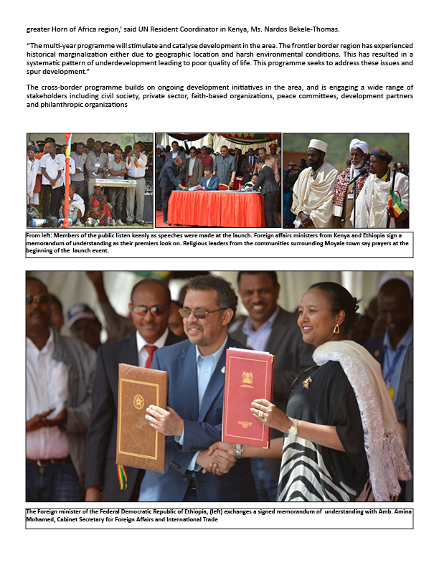

## Outcome 3: Enhanced mainstreaming of peacebuilding, reconciliation and community security in development agenda

* Gender perspectives integrated in plans, strategies, policies and mechanisms. This has seen over 60% of Local Peace Committees adhering to the not more than 2/3 of either gender principle in their composition.
* *Enhanced capacity of women and youth on peace, cohesion, mediation and reconciliation, in line with the Kenya National Action Plan (KNAP) on UN Security Council Resolution, UNSCR 1325. As a result,*a pool of peacemakers and cohesion agents established for Nakuru and Kisii Counties.
* Capacity of peace and security actors has enhanced on matters relating to Gender Based Violence;
* Strengthened coordination mechanisms - 40% increase in peacebuilding and cohesion coordination structures established, including Consultative Platform on Counter Violence Extremism (CVE);
* Approximately 40% of Counties made budgetary allocations for activities and strategies that support conflict management. Conversely, at least 50% of County Integrated Development Plans (CIDPs) have mainstreamed peacebuilding;
* Development of Social Cohesion Index has formed part of proposed formula for equalization fund adopted by Commission on Revenue Allocation (CRA). Some of the Social Cohesion Index parameters now form part of proposed formula that determine the needy counties for the equalization fund.
* The programme engaged Political leadership, Parliamentary committees as well as the Council of Governors through the Security and Foreign Relations Committee, in steering the peacebuilding, cohesion and conflict management discourse

Support to promoting national unity, reconciliation, cohesion, resilience and integration at national and county levels:

1. *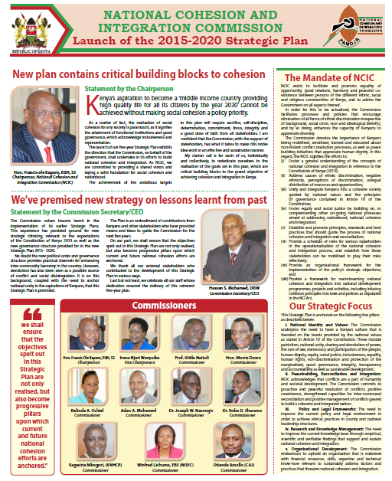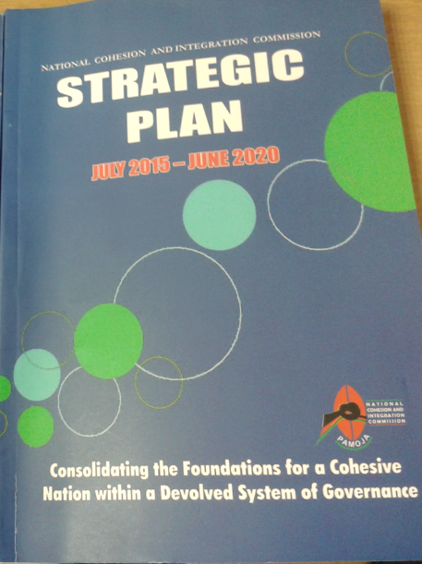****NCIC 2015-2020 Strategic Plan[6] developed and launched:*** focusing on “consolidating foundations for a cohesive nation within a devolved system of governance” was developed and launched in September 2015.
2. *Resolved, mitigated and transformed violent inter-ethnic conflict through Alternative Dispute Resolution (ADR) mechanisms such as arbitration, negotiation, mediation, facilitated dialogue and reconciliation.* Peace dialogues facilitated for peaceful co-existence in counties such as Marsabit, Meru, Samburu-Isiolo, Taita Taveta and Mount Elgon (Bungoma), among others. Community peace pacts (ceasefire and peace agreements) have been signed by warring communities which have resulted in peaceful co-existence and improved social cohesion amongst affected communities. These include, *Marsabit Boma Peace Agreement*; Tugen and the Ilchamus ceasefire agreement; Abbey Resort Resolutions for Mt. Elgon Sub-County[7]; the Lewa Downs Resolutions between communities in Isiolo and Samburu Counties; resolutions between Luhyas and Luos in Vihiga and Kisumu counties respectively regarding Maseno boundary conflict; Cross-border peace talks between the Karamoja of Uganda, Turkana of Kenya and Toposa of South Sudan led to sharing of pasture and water resources.

**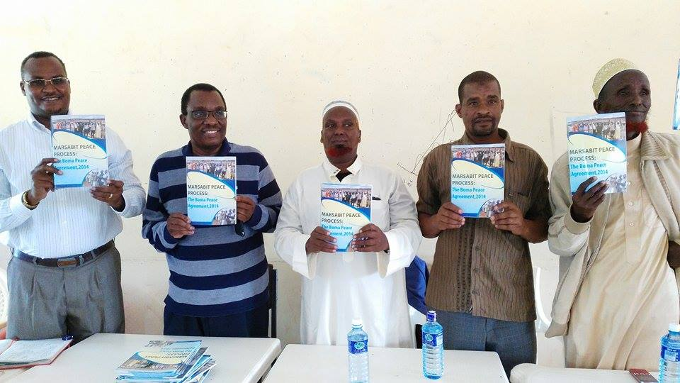*From Left Comm Dr.Roba Sharomo, comm Hon Morris Dzorro, Mr Ahmed Hapicha, Mr Wolasa Hasse and Mr. Hussein Kadida Holding the Marsabit Boma Peace Agreement***

*c) Peaceful co-existence enhanced in learning institutions* through establishment of *Amani* (peace) clubs in over 1000 primary and secondary schools. These clubs have enabled students to embrace peace-building practices within their institutions, mitigate institutional conflicts through dialogue, reconciliation and mediation mechanisms, and improve relationships between the schools and the community, through volunteerism.

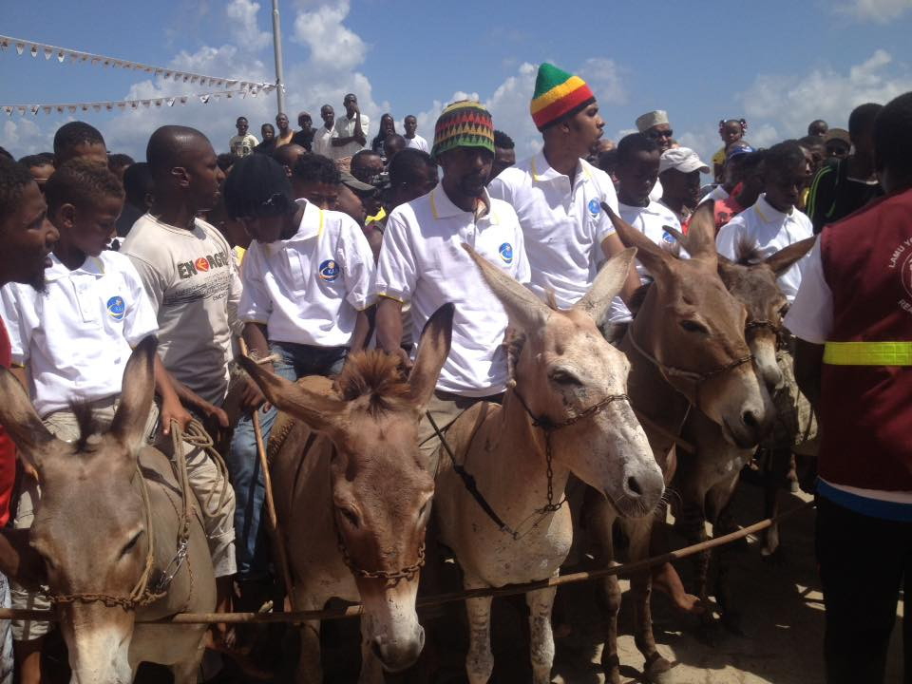d) In *appreciation of ethnic and cultural diversity*, NCIC supported and co-organised national and county cultural festivals such as Ura Gate Tharaka cultural festival (in August) and 15th Lamu Cultural Festival (in November), in a bid to strengthen capacity of institutions and communities to foster national identities and values, as well as peaceful coexistence;

e) *Ethnic and Diversity Audits targeting Parastatals, Commissions and County Governments conducted*, to ensure inclusivity and diversity compliance in recruitments, in line with Constitution of Kenya Article 249(1b) and Article 232(1h), and Section 7 of NCI Act, 2008. As a result, 1) Parastatals Diversity and Audit report has been prepared with an endorsement for State Corporations to work collaboratively with NCIC to facilitate a process of sensitization amongst State Corporations’ employment organs and Kenyans of different backgrounds on cohesion matters. 2) Ethnic auditing incorporated as part of annual reporting of Independent Commissions. 3) Key recommendations from the County Government Diversity and Audit report:

* Salaries and Remuneration Commission should harmonize salaries and schemes of service across counties to enable transfers;
* Council of Governors, chairs of County Public Service Boards, chairs of county assembly service boards and the Inter-Governmental Relations Agency should initiate an inter-county transfer system;
* NCIC, Counties and the Kenya National Bureau of Statistics should develop a County Minority Register (CMR) of the minority and marginalized communities with an aim of tracking the progressive attainment of inclusion and fair representation;
* County Public Service Boards should undertake annual ethnic and diversity audits of the county public service;
* Counties should bar use of local language in County Offices.

f) For the inaugural *Governors’ Award 2015[8]*, focusing on “Performance and Excellence”, a national cohesion and integration category was developed and adopted. Further, NCIC sponsored 10 banded trophies that were awarded to the winners under various categories. The main objective of the awards is to highlight the achievements of Governors mid-term during their tenure in office. The awards are merit-based and are centered on County Governors’ innovative and sustainable strategies that have greatest socio-economic impact in their respective counties.

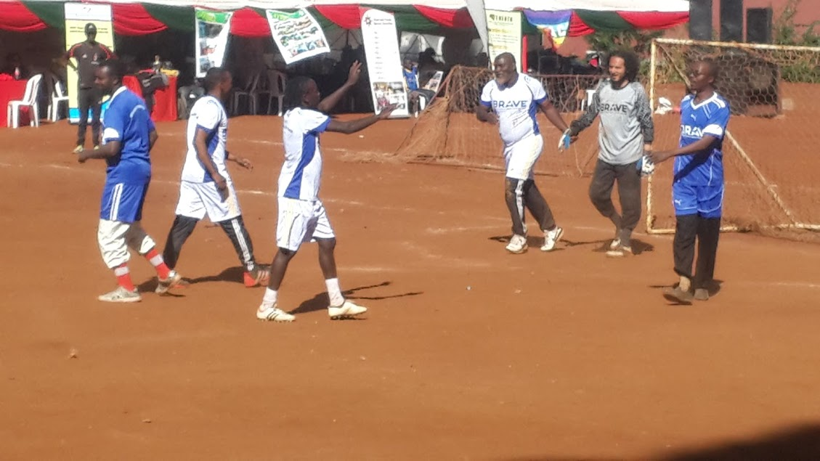g) *Enhanced respect and appreciation of diversity* among the youth has been realised through*Sports for Peace*initiatives bringingpersons of different religious and ethnic backgrounds e.g. Football for peace between Christians and Muslims at Olympic Primary School Grounds in Kibera, Nairobi

h) *‘Nairobi Peace Talks’[9] themed* ‘I Contribute to Peace’ organisedin the quest to expand space for dialogue around peace-building and conflict-resolution. NCIC partnered with Interpeace in organising the Peace Talks that provided a platform for individuals to share personal experiences and unique contributions to peacebuilding, as well as forge workable partnerships for peace promotion. 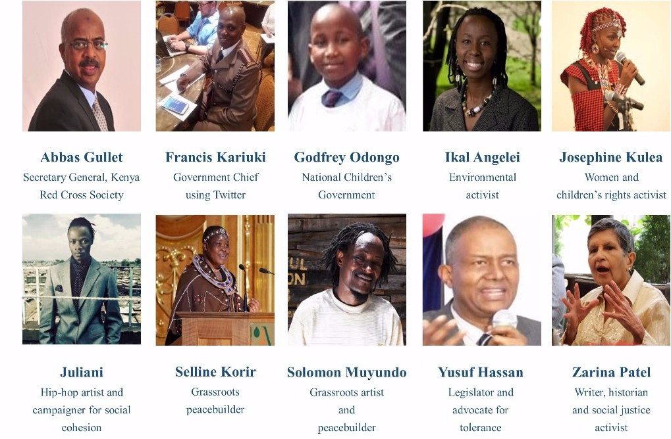***Speakers at the Nairobi Peace Talks***

i) Investigators from the Criminal Investigations Department and prosecutors from Director of Public Prosecutions office trained onunpacking and investigating hate speech; collecting and collating evidence to make a case and maximizing on legal mechanisms. This aimed at sensitising officers from Rift Valley, Western and Nyanza Regions on issues of enforcement, equipping them with investigative skills to enable them handle hate speech and ethnic contempt cases under the NCI Act.

*j) Violations of the NCI Act and relevant laws in cyberspace, monitored and investigated*. Between October-December 2015**,** NCIC received a total of twenty nine (**29**) **complaints** as per the table below:

|  |  |
| --- | --- |
| **Nature of Complaint** | **Number** |
| Religions Incitement | 1 |
| Ethnic Discrimination | 8 |
| Racial Contempt | 1 |
| Ethnic Contempt | 6 |
| Hate Speech | 17 |
| Outside Mandate | 5 |
| **Total** | **37** |

As a result,investigations on complaints received were undertaken; three (3) files have been forwarded to Office of the Director of Public Prosecutions, recommending prosecution; while investigations into the remaining files are ongoing.

## OUTCOME 4: Enhanced Results Based Management, strategic partnerships and coordination at the Programme level

Support to strengthening capacities for programme management, strategic partnerships and programme coordination:

In order to deliver quality results the Programme adopted a results based approach to programme management, with the primary focus on the quality and utility of products and services from the programme.

Training of the Programme Management Coordination Unit and the rest of the Implementing Partners in the programme on results-based reporting contributed to improved quality of reports submitted by Partners.

### Strategic engagements

* Programme continued to explore strategic partnerships with national and county actors.
* *Engagements with religious fraternity on countering violent extremism and radicalisation***:** Interfaith forums conducted bringing together Christian and Muslim communities as key opinion leaders in advocating for tolerance and peaceful co-existence among their followers, in a bid to address youth radicalisation and extremism. As a result, the religious stakeholders are working on rebuilding trust and good relations among their communities; including between the Muslim community and the law enforcement agencies; addressing underlying structural drivers of joining extremist groups; development of a counter-narrative against extremist ideology and narrative in liaison with religious scholars; formalization of the Madrasa curriculum and proper management of the institution of the mosque.

# VI. Challenges and Lessons Learned

## Challenges:

**Weakened Support to Local Peace Structures due to Reduced Financial Support:** During the onset of the reporting period, the program faced the challenge of inability to fully execute implementation plans. This was fundamentally due to financial constraints. Naturally, this also affected effective programme delivery and ultimately the outputs, results and outcomes of the programme. To mitigate this challenge, the Programme Board will consider diversifying its source of funding through lobbying for more support from the Government of Kenya, building strong linkages including co-funding arrangements with County Governments, and bringing more non-traditional partners into the programme.

**Staffing limitation** and stalled recruitments of Peace Coordinators and the Program Management and Coordination Unit, attributed to financial constraints. UNDP is in discussions with the Ministry of Interior and Coordination of National Government in addressing staffing needs for the peace infrastructure, given that the National Peace policy has been passed. Further consultations to be explored with the County governments in supporting peace structures especially at the county and grassroots levels in establishing and/or strengthening County Peace Forums, Local Peace Committees and County Peace Secretariats.

**Low Alerts and Incidents Reporting from Counties:** NCEWER witnessed reduced alert and incident reporting during the reporting period due to a number of factors including reduced presence of peace monitors on the ground (there are only 9 out of 47 peace monitors) and an outdated NCEWER Platform. The Programme Board has addressed this challenge by prioritizing and authorizing the *National Conflict Early Warning and Early Response System (NCEWERS to be updated, automated and engendered* paving way for devolution of the NCEWERS to County levels so as to facilitate effective and efficient vertical and horizontal response to conflicts.

**Changing Conflict Dynamics:**  political temperatures will start rising as the country approaches the next General Elections in 2017, thus posing a threat to the peace and stability gained, so far. Political intrigues fuelling emerging conflicts between communities, negative ethnicity/clannism, hate speech, transnational terrorism, youth radicalization and violent extremism, remnants of aggrieved groups, disasters triggering intercommunal conflicts and fierce competition over resources, remained a big threat to the peace and stability of the country, thus the need for sensitization on peaceful co-existence.

**Devolution-related conflicts:** devolution has brought with it myriads of challenges linked to power, resource sharing and management. Conflicts related to boundaries and extractives have become more pronounced, especially with the introduction of the devolved system of governance. This necessitates the need for synergetic approach between the two levels of governments and/or between County Governments.

**Coordination challenges:** amonginstitutions, policies and resources for peacebuilding and cohesion is evident. To address this, UWIANO platform for peace is being re-activated to serve as the national interagency coordination group, where the roles of the different partner agencies and institutions are clearly outlined for better coordination, and potential areas of engagement identified to avoid duplication of roles and wastage of resources.

**Social Media Monitoring:** remains a key challengeto enforcers of hate speech laws. The borderline between freedom of expression and hate speech, which cuts across jurisdictions and brings into play different and at times conflicting regulatory provisions, is very thin. To address the threat posed by social media users, NCIC set up a cyber-crime unit to monitor social media with a view of identifying and prosecuting persons found breaching the provisions of the NCI Act. Currently, there are over six cases in court of hate speech mongers identified by the proactive measures put in place by the Commission. One of the key challenges the Commission encounters includes the use of pseudonyms, which makes it difficult to identify culprits. NCIC, in partnership with the Media Council of Kenya, continue to sensitize bloggers from the media fraternity and encourage them to engage on issue-based discussions, rather than divisive and inciting comments, especially as the country gears up for the 2017 general elections.

## Lessons Learned:

* **Devolution** has created an **appetite for power and resources** at the grass roots level, which requires appropriate strategies to counter possible conflicts**,** hence the strategic engagements with COG and County Governments.
* **Sharing of conflict early warning information** horizontally and vertically (with local actors and response agencies)is key for timely response, and is less costly**.** Further, it improves conflict monitoring and reporting country wide by disseminating knowledge through focal persons in conflict hotspot areas. A permanent information flow is critical for the smooth running of the Conflict Early Warning and Early Response System located at the Situation Room at the NSC/PBCM Secretariat offices. A strong CEWER structure should include the establishment of CEWER hubs at County or sub-cluster levels to work with local communities and other stakeholders in order to enhance cooperation, collaboration and smooth information flow for peace initiatives and interventions by peace actors.
* **Synergy between National and County Level actors:** is critical for conflict prevention, management, resolution (CPMR) and peacebuilding processes. This is includes infusing inclusivity through CPMR strategies in the County Integrated Development Plans (CIDPs) for conflict sensitivity programing. Increasingly, County governments have recognized and identified peacebuilding, conflict management, cohesion and reconciliation as a critical function. As a result, some County Governments have set up offices responsible for this function and are funding peace and cohesion -related activities.
* **Managing partners’ expectations on available resources and timely disbursement** is critical for efficient programme implementation and results.
* **Improving Community Security, Peace and Social Cohesion, and Resilience Building**. As the program envisages that by 2018, counties and communities are supposed to be able to anticipate, prevent and respond effectively to disasters and emergencies. This is achievable through establishing institutional capacity to promote peacebuilding, conflict prevention and community security. There is need to enable communities engage in cross border peace initiative and to encourage synergies between counties especially in areas that are prone to conflicts, i.e. the 17 hotspot counties that have been identified by the program for implementation. Engagement with target stakeholders e.g. elders, youth, women, community leaders, politicians etc. are important component in improving community security and should always be engaged in PBCM initiatives at the grassroots levels.

# VII. Conclusions and Way Forward

The priorities of the programme going forward include:

* Strengthening the peace and cohesion infrastructure at 1) National level: inter-governmental coordination to reduce institutional overlaps; and 2) County Level:harmonize structures for peacebuilding and cohesion into county development plans.
* Leveraging on the macro analysis of conflicts in Kenya, as well as the scenarios postulated by stakeholders to inform strategic planning for conflict prevention, management and resolution towards a successful and peaceful general election in 2017.
* Elections security, policy dialogues, early warning, early response through confidence building initiatives such as UWIANO platform.
* Concerted effort towards operationalizing the UWIANO Platform for Peace with a review of the mandate and representation of stakeholders. The scope of the platform will cover the pre-election, election and post-election period of the upcoming 2017 General Elections.
* Advocacy for enactment and approval of pending bills and policies, such as the Small Arms and Light Weapons policy and bill. With the approval of the National Policy on Peacebuilding and Conflict Management, as well as passing of the Sessional Paper, the national context is set for preparation of the National Council Bill. This will ultimately create an environment for enhanced coordination, cooperation, consultation and collaboration of peacebuilding, conflict prevention, management and resolution interventions in Kenya.
* Strategic engagements with Council of Governors, parliament and CSOs in steering policy and legislative agenda for peace and cohesion- especially small arms, community security.
* Strengthened peace and conflict research, documentation and dissemination.
* CVE and radicalization -Current pilot is expected to expand into a new and integrated program incorporating social protection and rehabilitation interventions, more technical support on issues of policy reforms (support to harmonization of Madrassa education curriculum) and multi-purpose centres for youth development, employment and participation in decision making at county levels.
* Other Strategic initiatives: Conflict prevention and resilience building mechanisms; Youth and alternative livelihoods in conflict prone areas; Gender, SGBV and social protection mechanisms among vulnerable communities.

1. [Budget statement 2015-2016, The National Treasury](http://www.treasury.go.ke/downloads/category/31-budget-speeches.html)
2. [Nyumba kumi initiative has reduced crime says task force](https://citizentv.co.ke/news/nyumba-kumi-initiative-has-reduced-crime-says-task-force-104586/)
3. [President's speech during State of the Nation Address at Parliament - 26 March 2015](http://www.president.go.ke/2015/03/26/speech-by-his-excellency-hon-uhuru-kenyatta-c-g-h-president-and-commander-in-chief-of-the-defence-forces-of-the-republic-of-kenya-during-the-state-of-the-nation-address-at-parliament-buildings-na/) 
4. Protection Against Domestic Violence Act - <http://kenyalaw.org/kl/fileadmin/pdfdownloads/Acts/ProtectionAgainstDomesticViolenceAct_2015.pdf>
5. [www.srickenya.org](http://www.srickenya.org)
6. <http://cohesion.or.ke/images/downloads/NewspaperAdNation.pdf> - launched on 4th September 2015
7. Samburu-Turkana Ceasefire Agreement; Abbey Resort Resolutions (Mt Elgon) - <http://www.cohesion.or.ke/index.php/media-centre/press-statements/361-samburu-and-turkana-ceasefire-agreement>, ‘<http://www.mygov.go.ke/?p=4582>
8. <http://www.kepsa.or.ke/2015/08/28/governors-awards-2015-launch-at-serena-hotel-on-24th-august-2015/> ; http://sokodirectory.com/2015/10/governors-awards-to-be-held-on-30th-october-2015/
9. [**www.peacetalks.net**](http://interpeace.us11.list-manage.com/track/click?u=8db1d3578ca5ca63575cb0d6c&id=06f8e634d0&e=17239ede4a); [www.cohesion.or.ke/index.php/news-all/383-the-nairobi-peace-talks](http://www.cohesion.or.ke/index.php/news-all/383-the-nairobi-peace-talks)